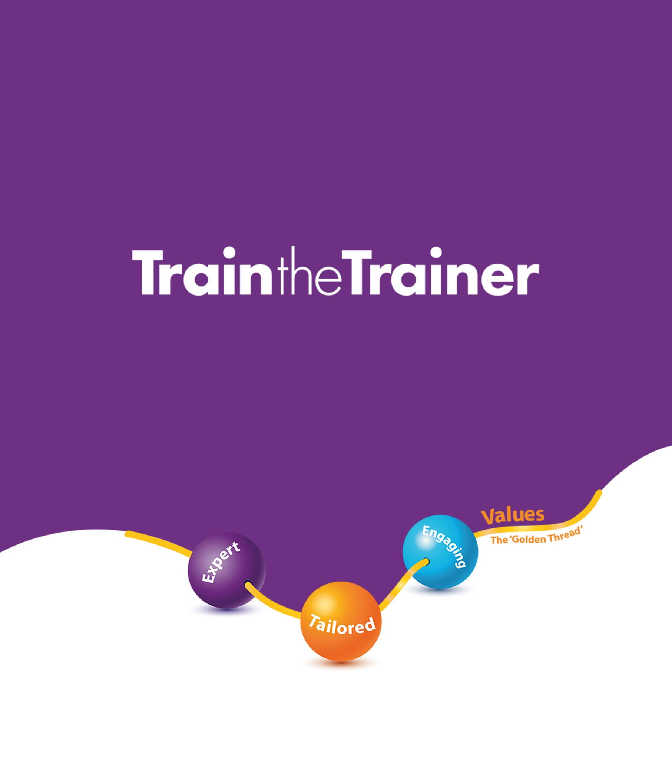

Application Form
Please complete all sections in this form and then return it to
trainthetrainer@transformyourtraining.org

We believe that delivering training is both a privilege and an opportunity. Our Train the Trainer Award is designed to help everyone involved—facilitators, delegates, customers, and organisations—reach their full potential.
This application form is intended for those who share our commitment to delivering high-quality training that makes a real impact.
Please answer the questions honestly and openly. All applicants are assessed based on their current learning needs, as it is important to us to provide an exceptional learning experience.
We select participants by carefully reviewing all applications and using our expertise to create a balanced cohort, ensuring a diverse mix of needs and perspectives. If you are not successful on this occasion, you may request feedback and ask to be placed on the priority assessment list for the next cohort.

We believe that quality training has the power to transform lives.

Preparation

In preparation and to help you complete this application, have you:
Watched Tammy’s Tedx Talk on How Values-Led Quality Training Has the Power to Transform Lives  Watch here | YES / NO
Completed the self-assessment against the methodology?  Methodology Assessment | YES / NO

Applicant Information

Full name:

Contact number:

Email:

Postal address:

Social media links:

Next of kin name/number:

Why are you applying for the Train the Trainer Award?

Do you have experience delivering training? If so, please tell us about it here.

What are your values and principles? How are they important to you and why?

Tell us three things you hope to gain by attending this course.

Please tell us three things you could support others with during this course.

What subjects do you deliver and what, if any, professional and/or personal experience do you have of these subjects? Is this experience current or historical?

Please also answer the following questions:

Do you have any access needs that we can support you with during your time on the course, including for your assessment and assignment? | YES / NO
If yes, please provide details below:

Want to know more?
Watched our podcasts?  YouTube Playlist Here | YES / NO
Watch Tammy’s Tedx Talk ‘Why Kindness Makes All the Difference’  Watch here | YES / NO
Read the book?  (new link to be added) | YES / NO
Join our mailing list | YES / NO

By signing below, you confirm that all the information contained within this form is correct (typing in your full name and e-mailing the form back will suffice).

Signature:

Date:

